**Registration#__2019-EE-383**

University of Engineering & Technology Lahore

Experiment # 4

Title: Z Transform-I

Equipment Required: Personal computer (PC) with windows operating system and MATLAB software

Theory:

Z transform is an important tool for the analysis and design of discrete time signals. It transforms a signal of time domain into a function of variable z. For discrete time signal x(n), z transform is defining as,

$$X\left[Z\right]= \sum_{n=-∞}^{∞}{x[n]Z^{-n}}$$

The properties of the z-transform are generalizations of the properties of the discrete-time Fourier transform.

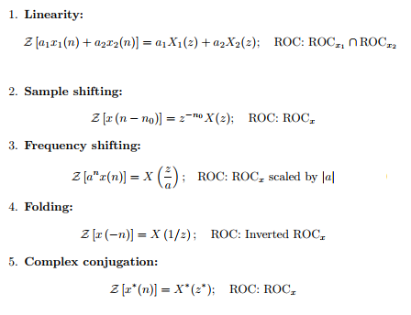

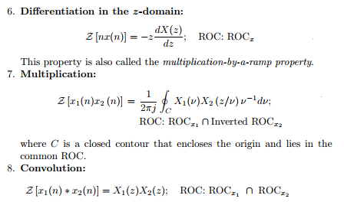

Example 1:

Find z transform of $x(n)= (1/4)^{n} u(n).$

$$>> syms z n$$

$$>> ztrans ({\left(\frac{1}{4}\right)}^{n})$$

Task#01:

# i) 𝒙(𝒏) = (𝟏/𝟒)𝒏 𝒖(−𝒏).

MATLAB Code:

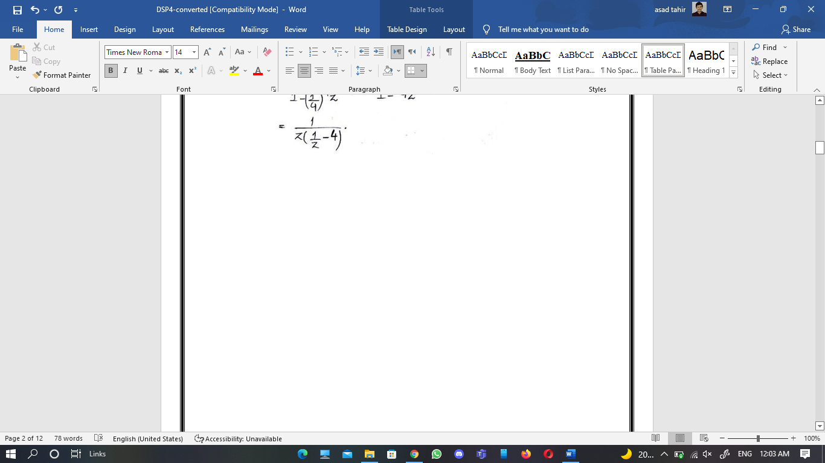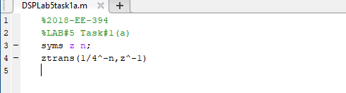

Output:

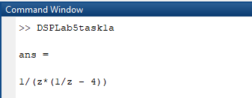

**Handwritten Solution:**

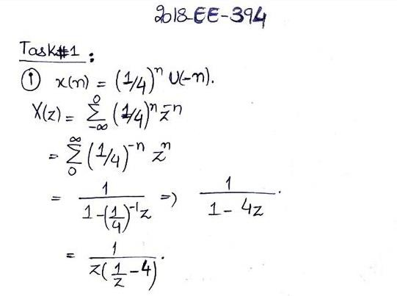

# 𝒊𝒊) 𝒙(𝑛) = (0.8)𝑛 𝑢(−𝑛 − 1).

MATLAB Code:

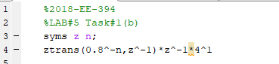

Handwritten Solution:

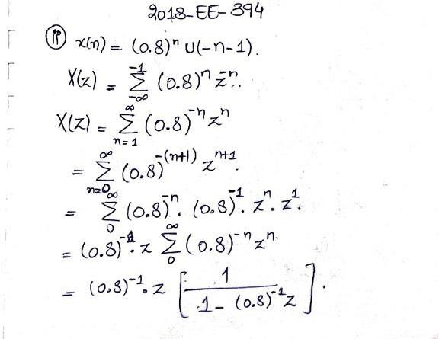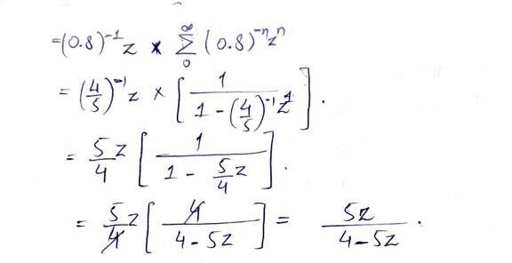

𝒊𝒊𝒊) 𝒙(𝒏) = (𝟒𝒏) 𝒖(𝟏 − 𝒏).

MATLAB Code:

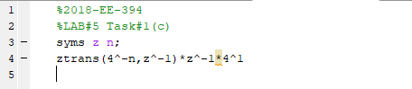

Output:

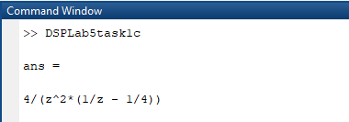

Handwritten Solution:

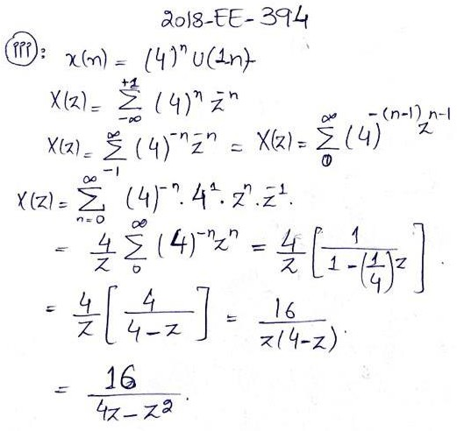

# 𝒊𝒗) 𝒙(𝒏) = (𝒏 + 𝟏)(𝟑𝒏−𝟐) 𝒖(𝒏).

MATLAB Code:

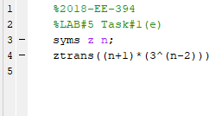

Output:

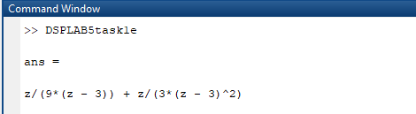

Handwritten Solution:

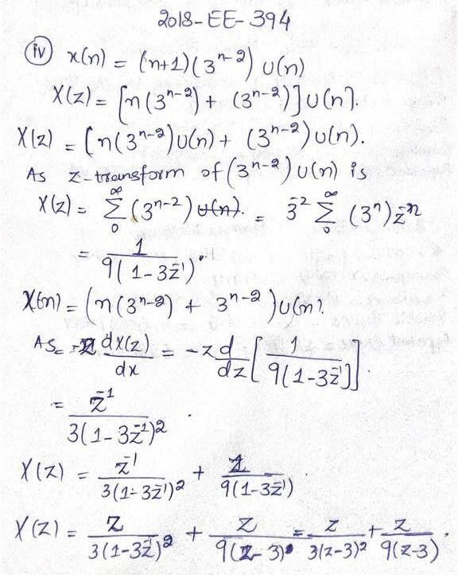

𝒗) 𝒙(𝒏) = 𝒏𝑺𝒊𝒏(𝝅𝒏/𝟑) 𝒖(𝒏) + (𝟎. 𝟗)𝒏 𝒖(𝒏 − 𝟏)

MATLAB Code:

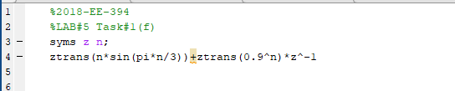

Output:

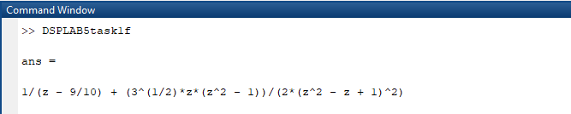

HandwrittenSolution:

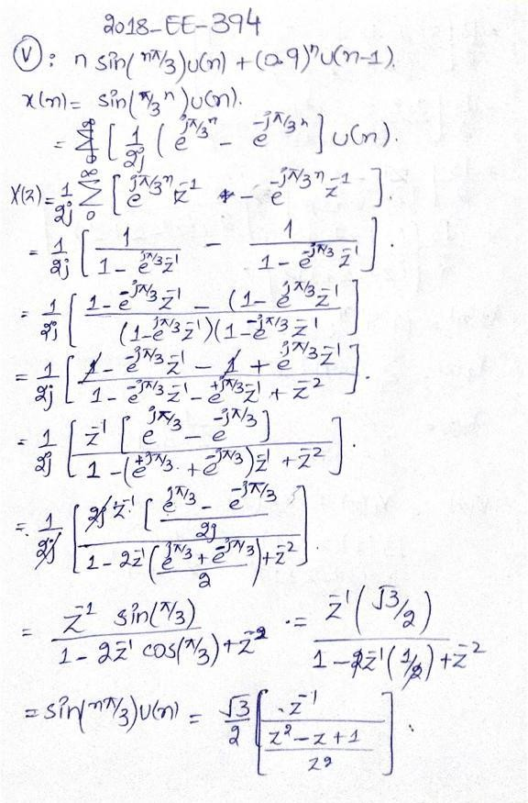

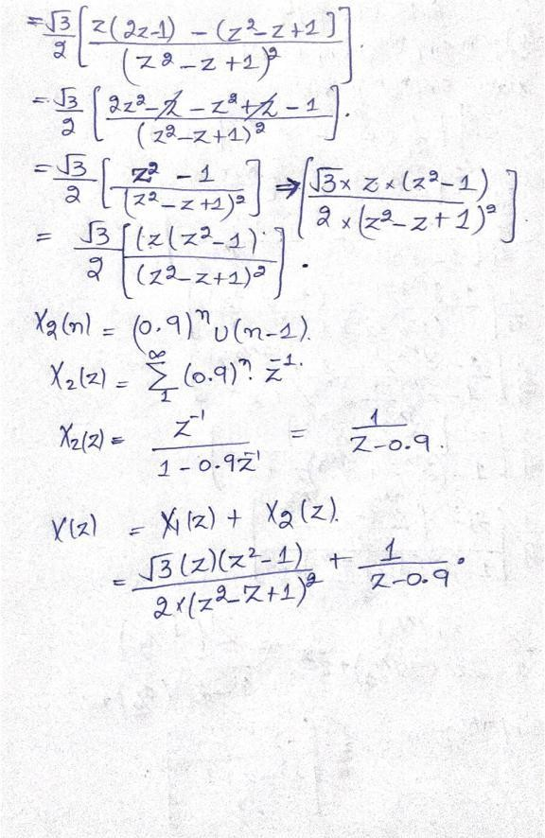

Task#02:

MATLAB Code:

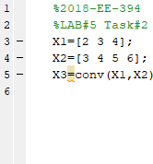

Output:

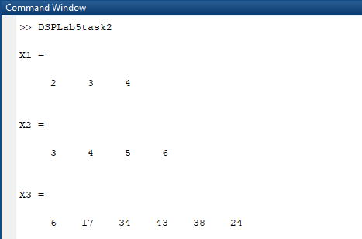

Handwritten Solution:

